Graphing Quadrilaterals Homework

On the graph below, graph a polygon that can be classified by ALL of the following:

Parallelogram, Square, and Rectangle

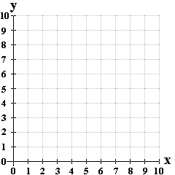

Write the four sets of coordinate pairs here:

How do you know the quadrilateral you graphed is a parallelogram, square, and rectangle? Explain below.

|  |
| --- |
|  |
|  |
|  |
|  |
|  |
|  |
|  |
|  |
|  |